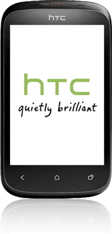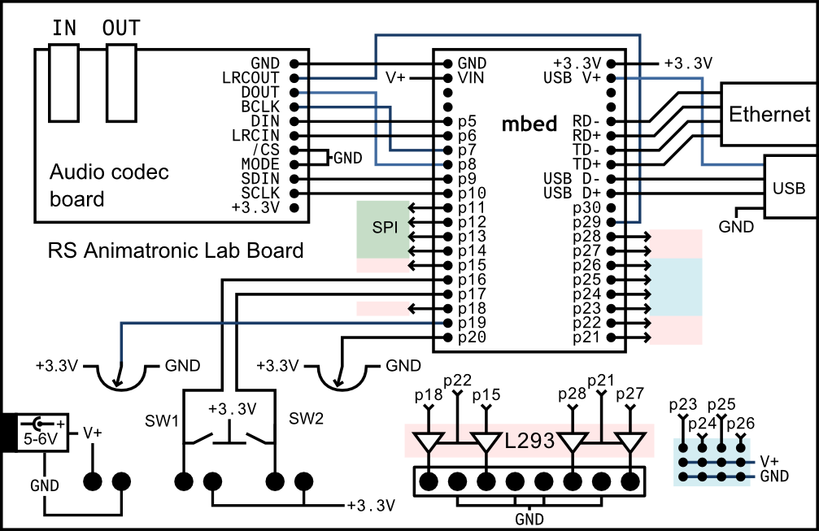

**Left Wheel Servo**

**Slave**

**Front Wheel Servo**

**Portable USB oplader**

**Batterijen op robot**

**Right Wheel Servo**